PASSWORD BASED CIRCUIT BREAKER

ABSTRACT
The project is designed to control a circuit breaker with help of a password only. A keypad is connected to the project to enter the password. Fatal electrical accidents to the line man are increasing during the electric line repair due to the lack of communication and co-ordination between the maintenance staff and the electric substation staff.
This proposed system provides a solution, which can ensure the safety of the maintenance staff e.g. line man. The control to turn ON/OFF the line lies with the line man only. This system has an arrangement such that a password is required to operate the circuit breaker (ON/OFF). Line man can turn off the supply and comfortably repair it, and return to the substation, then turn on the line by entering the correct password.
The system is fully controlled by a microcontroller from PIC family. A matrix keypad is interfaced to the microcontroller to enter the password. The entered password is compared with the password stored in the ROM of the microcontroller. If the password entered is correct, then only the line can be turned ON/OFF. Activation / deactivation of the circuit breaker is indicated by a lamp (ON/OFF).
Further the project can be enhanced by using an EEPROM for user to change the password for a more secured system. It can also be interfaced with a GSM modem for remotely controlling the circuit breaker via SMS.

BLOCK DIAGRAM
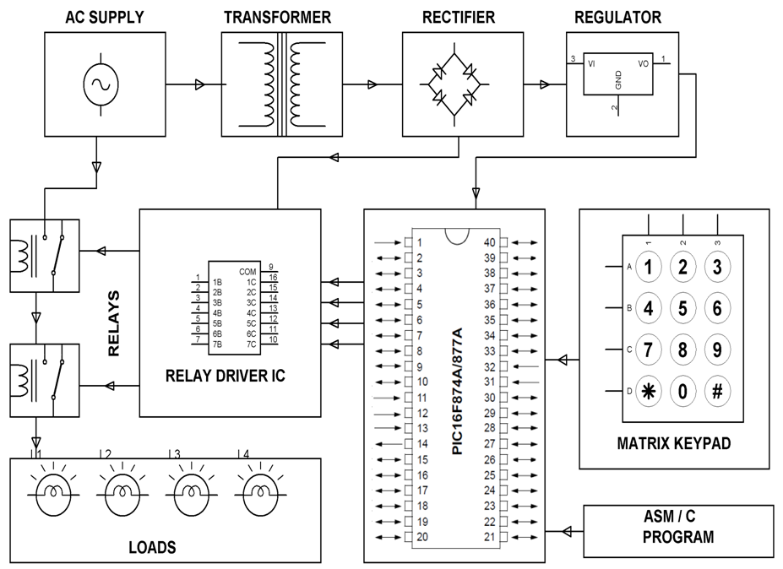

HARDWARE REQUIREMENTS:
PIC series Microcontroller, Relay Driver IC, Relays, Matrix Keypad, Crystal, Resistors, Capacitors, Diodes, LED, Transformer, Voltage Regulator, Lamps.

SOFTWARE REQUIREMENTS:
HI-TECH PICC Tool suite
Language: Embedded C or Assembly

